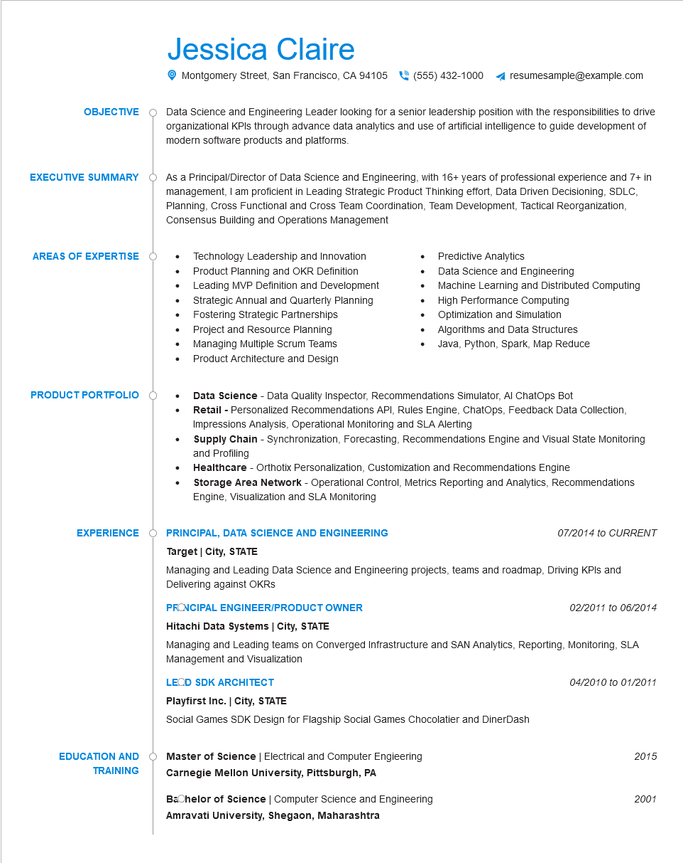
OBJECTIVE
EXECUTIVE SUMMARY
AREAS OF EXPERTISE
PRODUCT PORTFOLIO
Jessica Claire
Montgomery Street, San Francisco, CA 94105 (555) 432-1000
resumesample@example.com
Data Science and Engineering Leader looking for a senior leadership position with the responsibilities to drive organizational KPIs through advance data analytics and use of artificial intelligence to guide development of modern software products and platforms.
As a Principal/Director of Data Science and Engineering, with 16+ years of professional experience and 7+ in management, I am proficient in Leading Strategic Product Thinking effort, Data Driven Decisioning, SDLC, Planning, Cross Functional and Cross Team Coordination, Team Development, Tactical Reorganization, Consensus Building and Operations Management
• Technology Leadership and Innovation
•
Product Planning and OKR Definition
Leading MVP Definition and Development Strategic Annual and Quarterly Planning
• Fostering Strategic Partnerships
Project and Resource Planning
Managing Multiple Scrum Teams
•
•
Predictive Analytics
Data Science and Engineering
Machine Learning and Distributed Computing
High Performance Computing
Optimization and Simulation
Algorithms and Data Structures Java, Python, Spark, Map Reduce
Product Architecture and Design
Data Science - Data Quality Inspector, Recommendations Simulator, Al ChatOps Bot
· Retail - Personalized Recommendations API, Rules Engine, ChatOps, Feedback Data Collection, Impressions Analysis, Operational Monitoring and SLA Alerting
•
•
Supply Chain - Synchronization, Forecasting, Recommendations Engine and Visual State Monitoring and Profiling
Healthcare - Orthotix Personalization, Customization and Recommendations Engine
Storage Area Network - Operational Control, Metrics Reporting and Analytics, Recommendations Engine, Visualization and SLA Monitoring
EXPERIENCE
PRINCIPAL, DATA SCIENCE AND ENGINEERING
Target City, STATE
07/2014 to CURRENT
Managing and Leading Data Science and Engineering projects, teams and roadmap, Driving KPIs and Delivering against OKRS
PRONCIPAL ENGINEER/PRODUCT OWNER
Hitachi Data Systems | City, STATE
02/2011 to 06/2014
Managing and Leading teams on Converged Infrastructure and SAN Analytics, Reporting, Monitoring, SLA Management and Visualization
LEOD SDK ARCHITECT
Playfirst Inc. | City, STATE
Social Games SDK Design for Flagship Social Games Chocolatier and DinerDash
EDUCATION AND TRAINING
Master of Science | Electrical and Computer Engieering Carnegie Mellon University, Pittsburgh, PA
Bachelor of Science | Computer Science and Engineering Amravati University, Shegaon, Maharashtra
04/2010 to 01/2011
2015
2001

